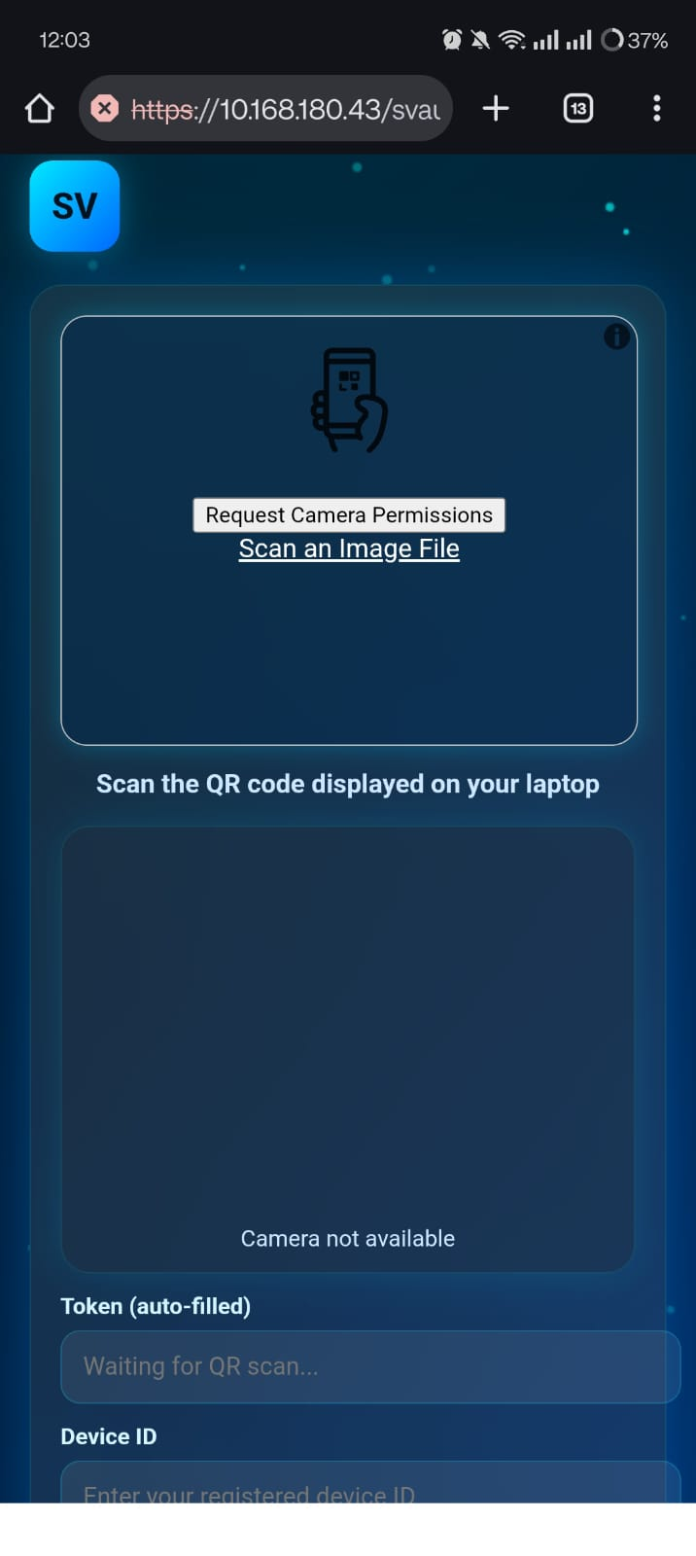
Figure 3.1: Secured Vault Dashboard Displaying Encrypted Password Entries
This dashboard provides users with a centralized interface to securely manage stored credentials, access security tools, and monitor account activity.

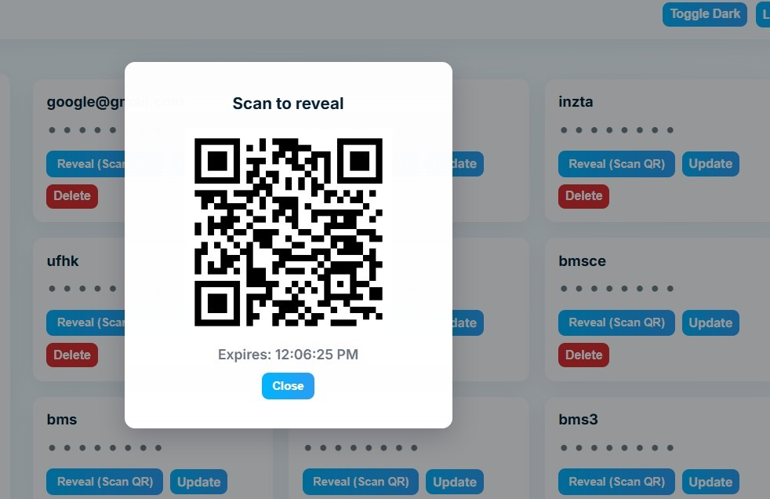
Figure 3.2: QR-Based Authentication Popup for Secure Password Reveal
A dynamic QR code is generated before revealing sensitive passwords, ensuring an additional layer of authentication.
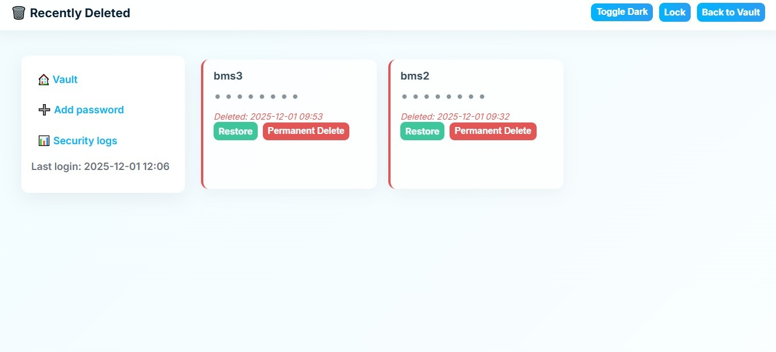
Figure 3.3: Recently Deleted Passwords Recovery
Deleted credentials are moved to a recovery section where they can be restored or permanently removed.

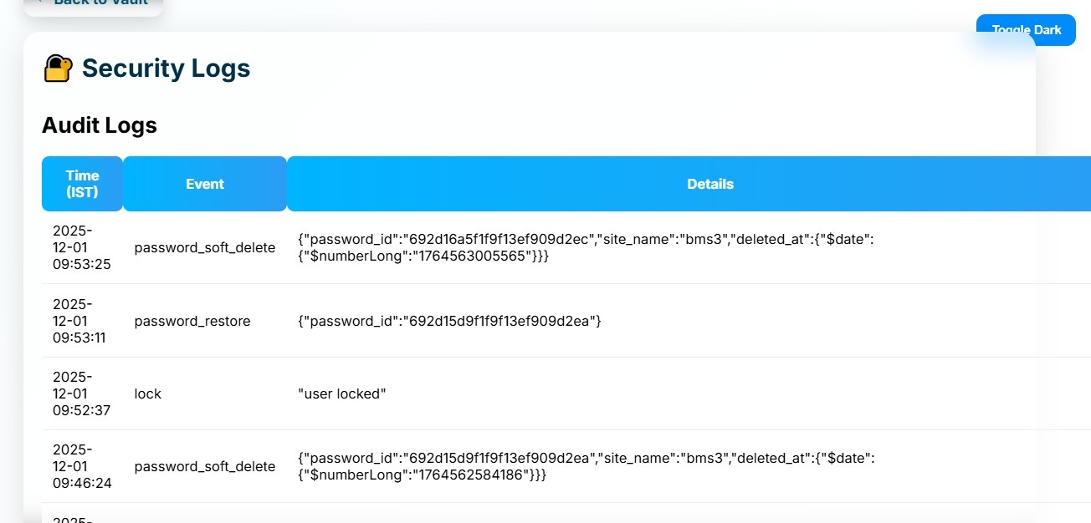
Figure 3.4: QR Authentication with Expiry Timer
The QR code remains valid only for a limited duration, reducing the risk of replay attacks.
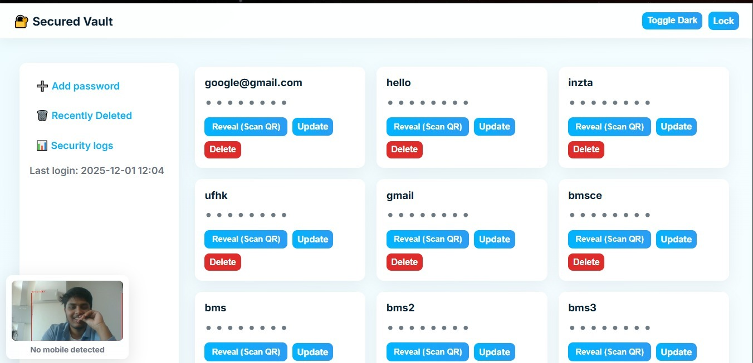
Figure 3.5: Security Audit Logs
The application records login attempts, password operations, and authentication events for auditing and monitoring.

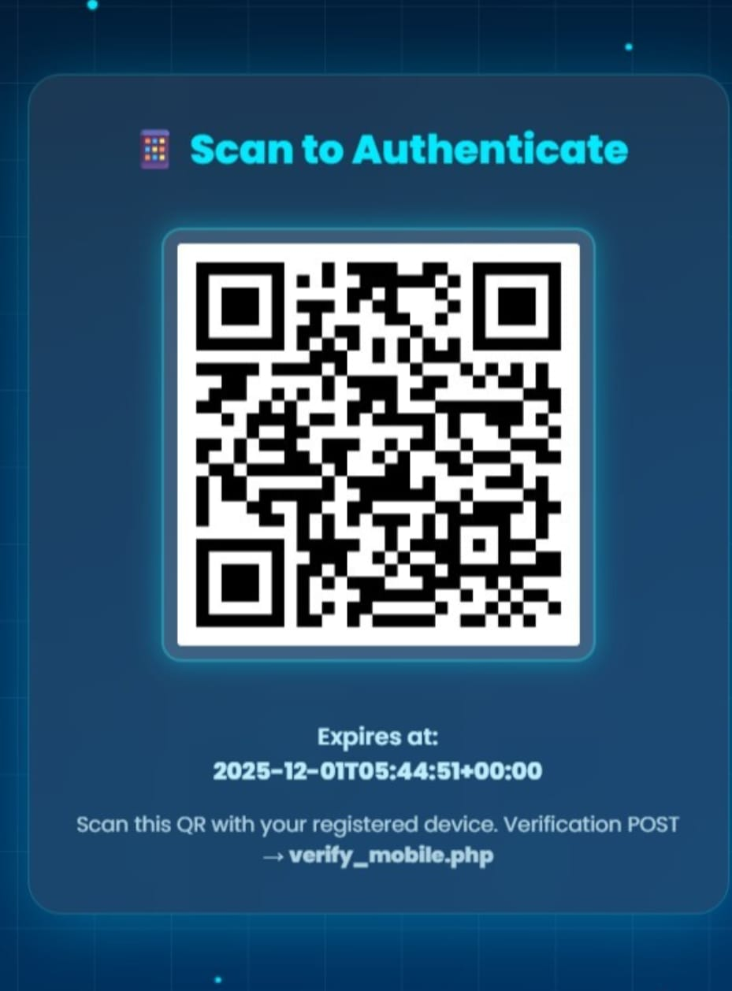
Figure 3.6: Last Access Location Tracking
Displays the geographical location of the most recent successful login to help users identify unauthorized access.

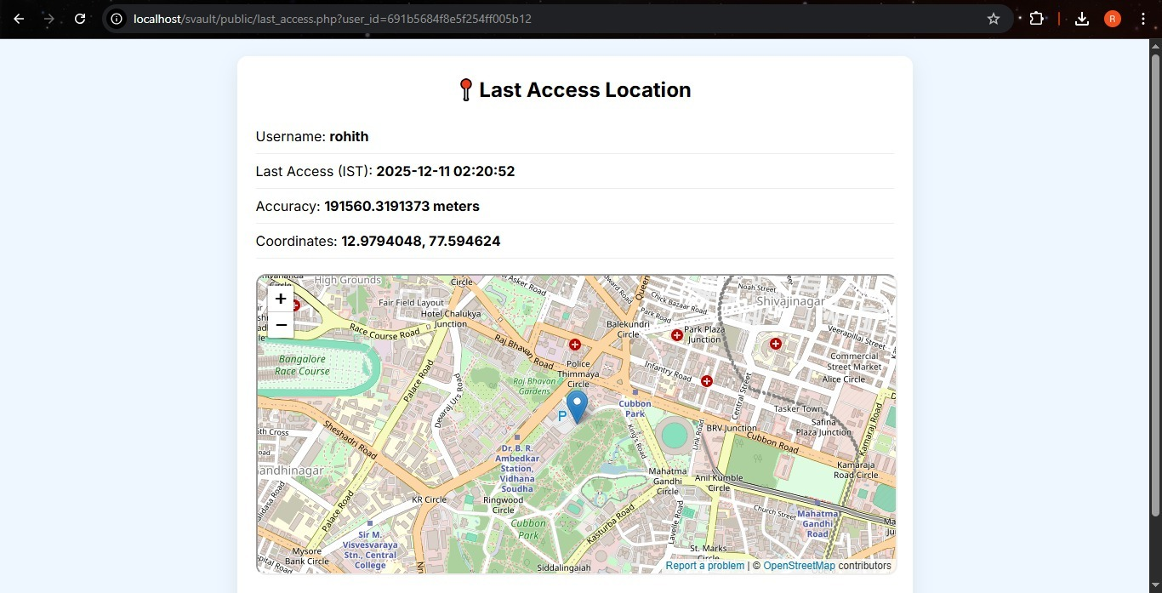
Figure 3.7: Password Breach Checker
Checks whether stored passwords have appeared in known data breaches and advises users to update compromised credentials.
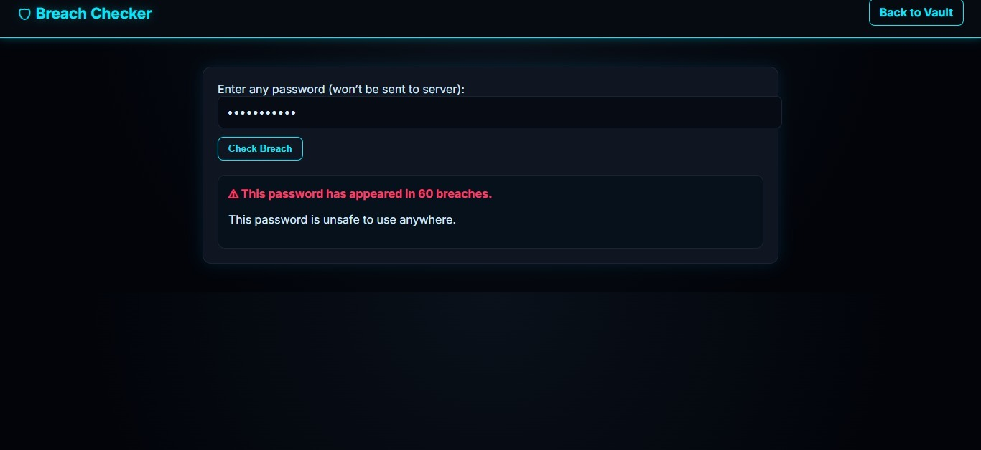
Figure 3.8: Password Strength Analyzer
Evaluates password complexity and estimates resistance against brute-force attacks.

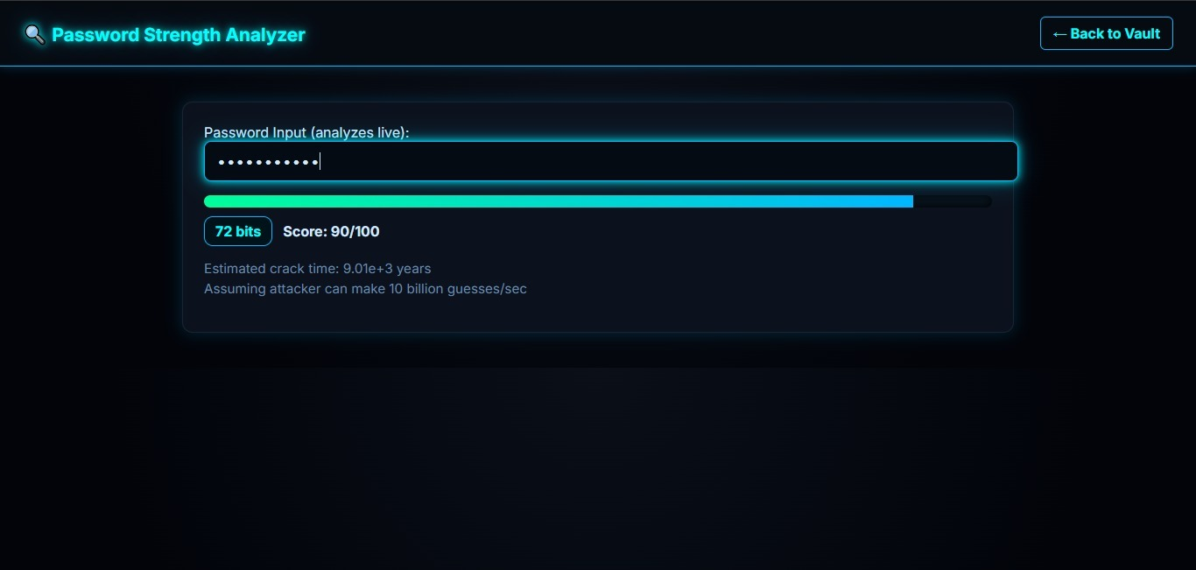
Figure 3.9: Mobile QR Verification
The mobile application scans the generated QR code to verify the user's identity before granting access.
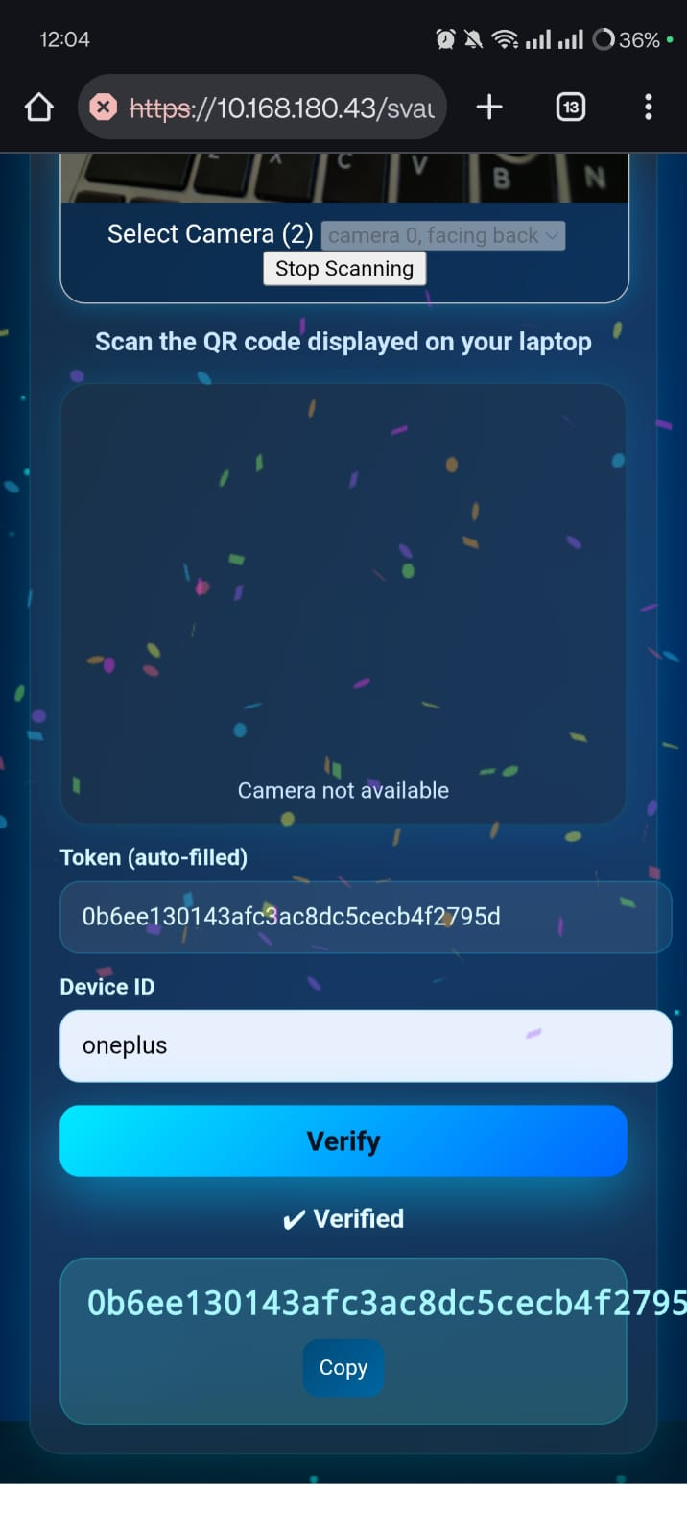
Figure 3.10: QR Scanner Permission Screen
The mobile device requests camera access to scan the authentication QR code securely.

